**QUESTION 1**

**#include <stdio.h>**

**struct Student**

**{**

**char name[50];**

**int age;**

**float tot;**

**};**

**int main()**

**{**

**struct Student s1,s2;**

**float average;**

**printf("Input details for the first student:\n");**

**printf("Name: ");**

**scanf("%s",s1.name);**

**printf("Age: ");**

**scanf("%d",&s1.age);**

**printf("Total Marks: ");**

**scanf("%f",&s1.tot);**

**printf("Input details for the second student:\n");**

**printf("Name: ");**

**scanf("%s",s2.name);**

**printf("Age: ");**

**scanf("%d",&s2.age);**

**printf("Total Marks: ");**

**scanf("%f",&s2.tot);**

**printf("Details of the first student:\n");**

**printf("Name: %s\n",s1.name);**

**printf("Age: %d\n",s1.age);**

**printf("Total Marks: %.2f\n",s1.tot);**

**printf("Details of the second student:\n");**

**printf("Name: %s\n",s2.name);**

**printf("Age: %d\n",s2.age);**

**printf("Total Marks: %.2f\n",s2.tot);**

**average=(s1.tot+s2.tot)/2;**

**printf("Average of total marks: %.2f\n",average);**

**return 0;**

**}**

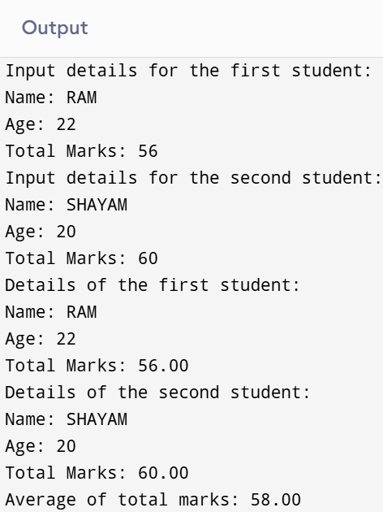

**QUESTION 2**

**#include <stdio.h>**

**#include <string.h>**

**struct Car**

**{**

**int carID;**

**char model[50];**

**float rent;**

**};**

**int main()**

**{**

**struct Car cars[3];**

**int i,days;**

**float totalCost;**

**printf("Enter details for 3 cars:\n");**

**for (i=0;i<3;i++)**

**{**

**printf("Car %d:\n",i+1);**

**printf("Enter Car ID: ");**

**scanf("%d",&cars[i].carID);**

**printf("Enter Car Model: ");**

**scanf("%s",cars[i].model);**

**printf("Enter Rental Rate per Day: ");**

**scanf("%f",&cars[i].rent);**

**}**

**printf("Enter the number of days for rental: ");**

**scanf("%d",&days);**

**printf("Total rental costs:\n");**

**for (i=0;i<3;i++)**

**{**

**totalCost = cars[i].rent*days;**

**printf("Car %d (Model: %s): Total Cost = %.2f\n",**

**cars[i].carID, cars[i].model, totalCost);**

**}**

**return 0;**

**}**

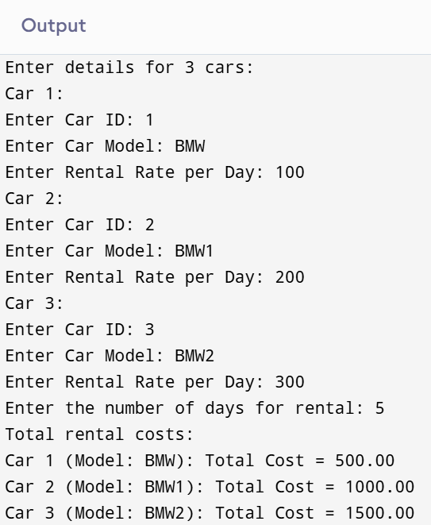

**QUESTION 3**

**#include<stdio.h>**

**typedef struct**

**{**

**double real;**

**double imag;**

**} Complex;**

**Complex add(Complex c1,Complex c2)**

**{**

**Complex result;**

**result.real=c1.real+c2.real;**

**result.imag=c1.imag+c2.imag;**

**return result;**

**}**

**Complex multiply(Complex c1,Complex c2)**

**{**

**Complex result;**

**result.real=c1.real*c2.real-c1.imag*c2.imag;**

**result.imag=c1.real*c2.imag+c1.imag*c2.real;**

**return result;**

**}**

**int main()**

**{**

**Complex n1,n2,sum,product;**

**printf("Enter the real and imaginary parts of the first complex number: ");**

**scanf("%lf %lf",&n1.real,&n1.imag);**

**printf("Enter the real and imaginary parts of the second complex number: ");**

**scanf("%lf %lf",&n2.real,&n2.imag);**

**sum=add(n1,n2);**

**product=multiply(n1,n2);**

**printf("Sum: %.2f + %.2fi\n",sum.real,sum.imag);**

**printf("Product: %.2f + %.2fi\n",product.real,product.imag);**

**return 0;**

**}**

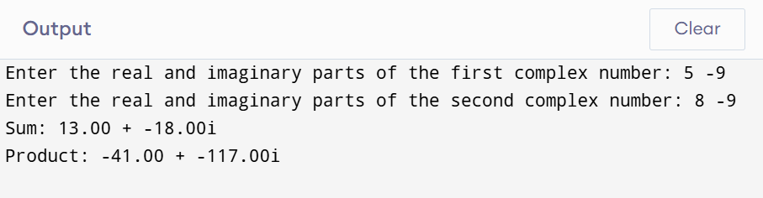

**QUESTION 4**

**#include <stdio.h>**

**#include <stdlib.h>**

**#include <string.h>**

**typedef struct**

**{**

**char name[100];**

**int id;**

**float salary;**

**}Employee;**

**int main()**

**{**

**int n;**

**Employee *employees;**

**printf("Enter the number of employees: ");**

**scanf("%d",&n);**

**employees=(Employee*)malloc(n*sizeof(Employee));**

**for (int i=0;i<n;i++)**

**{**

**printf("Enter details for employee %d:\n",i+1);**

**printf("Name: ");**

**scanf(" %s",employees[i].name);**

**printf("ID: ");**

**scanf("%d",&employees[i].id);**

**printf("Salary: ");**

**scanf("%f",&employees[i].salary);**

**}**

**printf("Employee Details:\n");**

**for (int i=0;i<n;i++)**

**{**

**printf("Employee %d:\n",i+1);**

**printf("Name: %s\n",employees[i].name);**

**printf("ID: %d\n",employees[i].id);**

**printf("Salary: %.2f\n",employees[i].salary);**

**}**

**free(employees);**

**return 0;**

**}**



